Assessment Team / Document Control Who might be harmed? (Yes / No)
RA Ref: SS 04 – West Way Sports Hub
Activity: Track and Field Athletic Activities Athletes / participants Yes
If a review or changes are made to the content of this risk assessment, the amended assessment must be forwarded to contact@chorley-athletic-and-triathlon.org for review and uploading on to CAAT website
Location / address: West Way Sports Hub, West Way, Chorley. PR7 6DJ Coaches / volunteers: Yes
Approved by: Simon Townsend Visitor/s: Yes
Approved date: 2024/11 Members of the public: Yes
Task: Provision of training and coaching with specific athlete grouping | Overall Risk Rating: | Low | Medium | High
  x
Review date and reason (regular review or straightaway): 2026/11

Generic supportive controls:
CAAT AGM and Constitution governs and outlining clubs objectives, roles, responsibilities, equal opportunities, child / adult protection and sub committees.
CAAT Code of Conduct covers principles for vulnerable child / adults, coaches, parents, athletes and juniors to ensure respect, integrity, standards, inclusivity and diversity.
CAAT Committee reviews, meetings and AGM ensures appropriate compliance and governance of club.
CAAT Coach meetings help continuous development of suitable training plans and safe training sessions leading to successful participation of sporting events.
CAAT MOJO club membership governs attendees and emergency contacts at training session, incidents or injury shall be reported using accident reporting form .
CAAT Website contains membership, training and competition information and is governed by privacy terms and conditions.
CAAT Safeguarding is overseen by key contacts, all coaches are DBS certificated and volunteers either self-certify or have appropriate level DBS.
CAAT has approved risk assessments (RA) for training and events. Site Specific Risk Assessment (SSRA) covering training venues and a COVID RA covering infection/ hygiene. These shall be referenced in collaboration with other relevant controls measures and instructions to form CAAT’s Emergency Action Plan (EAP) and safety arrangements.
CAAT operates within Public Health England, UKA, EA, BTF and TE guideline to ensure there is a healthy and safe pathway to training and racing.
CAAT coach to carry club provided first aid kits to all training and kit left in storage container. First aider coverage reviewed periodically, first aid contents reviewed after use and annually for expiry dates.
Other supportive Information
Defibrillator Location: side of main building adjacent to car park + Phone 999 for guidance and support.
Venue First Aid: First aider on site + first aid kit at reception
Site Responsible Person Contact: Team at reception, Duty manager Rachael Martin 08983515610
Hospital: Chorley and South Ribble Hospital, Preston Rd, Chorley PR7 1PP. Phone: 01257 261222 Royal Preston Hospital, Sharoe Green Lane, Fulwood, Preston PR2 9HT 01772 716565

Lost / missing athlete from group session | Athlete physical or mental distress, injury to person, | - MOJO booking in shall be used to record attendance  - Coach to athlete ratio shall be within guidelines of UKA/BTF / Gov.uk and appropriate for activities / athletes’ age and ability  - Coach has set session with safeguarding in mind to oversee athletes  - Clear instructions to athletes on arrangements in place and who are the coaches / parent’s supporting session  - Athlete understands which coach and parent is overseeing them  - Use of buddy system encouraged if athlete goes to use toilet facilities.  - Coach to take mobile phone and implement ICE follow up as required  - Any incident reported to safeguarding team member | Low
Slip trip and fall | Athlete  Parent /RP, coach, member of public. physical distress, injury to person. | - Follow activity RA to ensure safe use, handling and maintain of equipment  - Change footwear from field to track activities to help reduce debris and contamination of running surface.  - Equipment not in use to be safely located on site, stored in container, or returned back to vehicle on car park. | Low
Incident leading to requirement of Emergency Action Plans (EAP) / evacuation | Athlete, parent / RP, and coach | - Approved RA, and SSRA detailing EAP based on the type of training, athlete participants, location and type of training /event.  Training to start at one of the two locations A&B rendezvous points unless otherwise stipulated  - Entrance to track via path passed main building  - At the car park footpath central to pitches  ICE evacuation point A, if compromised then point B  West Way EAP map to help illustrate locations  Lead coach to oversee EAP and to help ensure all athletes are safe, inform / work with site responsible person, contact athletes RP for athletes as required. Inform safeguarding lead as required, | Low
Poor safeguarding | Athlete  Parent /RP, coach, member of public. physical or mental distress, injury to person, | - Coach understands of West Way privacy policy and safeguarding policy Please advise  - Coaches and volunteer’s compliance with code of conduct.  - Prior to session or event undertake a dynamic assessment risk assessment of training area/s and observe who is within proximity of the activities.  - Evaluate your observations and consider possible risks to athletes / members of public, adjust training session, relocated, or cancel as appropriate.  - Check in with athletes that they are healthy and well prior to training and ask them to highlight any issues arising when training  - Undertake continual dynamic risk assessments during sessions and take suitable intervention or actions to keep athletes / members of public safe,  - Have a clear communication channels and rendezvous point/s agreed with parents ICE for if training or event is cancelled prior or during | Low | Westway Operational Manager to send on West Way safe guarding policy and privacy policy. Philip Watson to review and amend CAAT risk controls were appropriate.
Other facility users | Athlete, coach, parent, Injury to person from physical activities or other users | - Undertake dynamic risk assessment of the weather prior to training and ensure athlete/s are suitably prepared for weather conditions i.e. heat, sunshine, wet, cold, ice, wind,  - Undertake dynamic risk assessment of the terrain prior to training / event and ensure athlete/s have appropriate instruction and footwear for the ground conditions  - Review area for obstructions and hazards such as damaged track surface, to remove or reduce potential risk to athletes by highlighting area or divert from hazard.  - Review other activities taking place in close proximity to help ensure social distancing and safe training areas. Mark out area as required and use marshals / support as appropriate to help facilitate safe training/event.  - Coaches to liaise with one another regarding lanes / areas in use.  - Track etiquette to be demonstrated and encouraged by coaches.  - Coach to carry first aid kit and be able to apply appropriate first aid response or make suitable arrangements to get athlete medical care. | Low
Infection transmission and poor hygiene | Athlete, coach, parent / RP and members of public | - Compliance with COVID secure RA  - Compliance with West Way Sports Hub controls measures and EAP  - Athletes, parents and coaches to undertaken personal good hygiene practices prior to training and afterwards per Public Health England guidance.  - The coaches training session or event is suitable to avoid unnecessary foreseeable transmission of infection or disease (per COVID secure RA) | Low | Westway Operational Manager to send on West Way risk assessment and emergency arrangements. Philip Watson to review and amend CAAT risk controls were appropriate.
Poor welfare facilities | Athlete, coach, parent / RP | - Toilets and washing facilities in main building leading to track  - No child to access public welfare facilities during training session without suitable RP or buddy system used. | Low
Equipment stored on site | Coach, Athlete and Parent / RP | - Coach and approved persons only access storage facility on site  - Equipment to suitability stored  - No flammable or chemicals to be stored within container  - Container to be secure and locked when not in use  - Racking and lighting within container TBC  - Dedicated storage key holders / key at reception. | Low
Drawings / supportive detail as required:

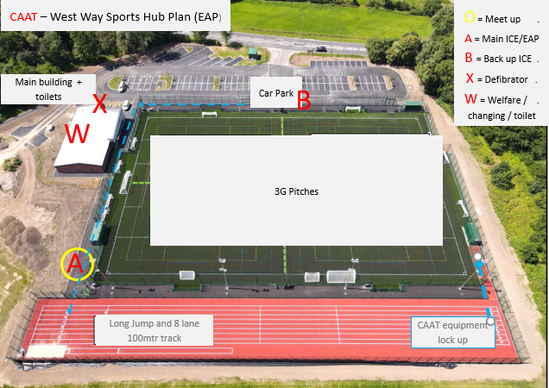
2 x 3G Pitches

